Project 2 (DATABASE)

Ken Zou

last four digits: 7338

CS331-8158

Submission date: 4/16/2017

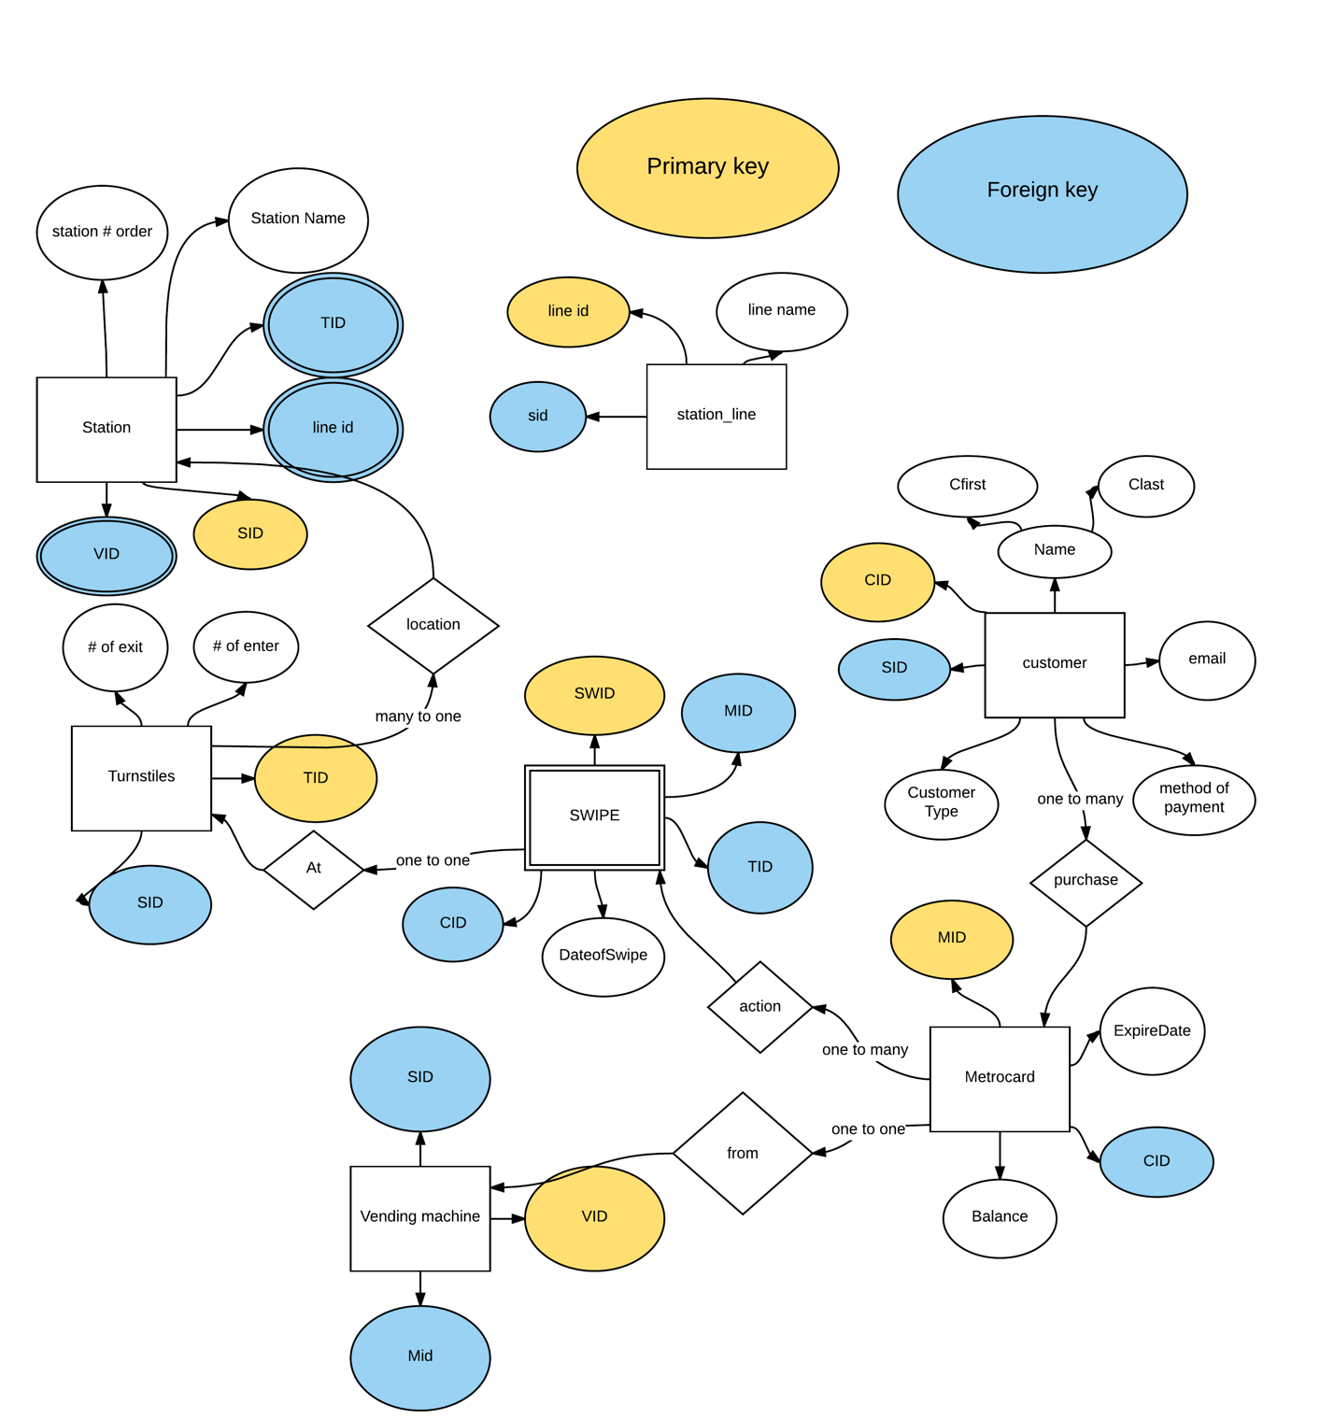

**ER to relation (to match project usage)**

Station(SID,sname, station # order)

Station_line(lineid,sid,linename)

Customer(CID,clastname,cfirstname,email)

Customer_method(methodid,cid,mtype)

Customers_fare(fareid,cid,faretype,farecost)

Turnstiles(TID,SID, number of exits)

Metrocard(MID,balance,CID,expire date)

Swipe(SWID,MID,CID,TID,Dateofswipe,syear,smonth,sday)

Vending machine(VID,MID,SID)

CREATE TABLE "CUSTOMERS"

( "CID" NUMBER(*,0),

"CLASTNAME" VARCHAR2(50),

"CFIRSTNAME" VARCHAR2(50),

"FAREID" NUMBER(*,0),

PRIMARY KEY ("CID") ENABLE

) ;

create sequence seq_customer

start with 6 increment by 5;

insert into customer(CID, clastname,Cfirstname CTYPE,SID,METHODID,EMAILID)

values(seq_customer.nextval,'smith','bob','senior',10,70,100);

insert into customer(CID, clastname,Cfirstname CTYPE,SID,METHODID,EMAILID)

values(seq_customer.nextval,'zou','ken','student',12,72,101);

insert into customer(CID, clastname,Cfirstname CTYPE,SID,METHODID,EMAILID)

values(seq_customer.nextval,'chen','allen','student',14,74,102);

insert into customer(CID, clastname,Cfirstname CTYPE,SID,METHODID,EMAILID)

values(seq_customer.nextval,'chen', 'alex','student',16,76,103);

insert into customer(CID, clastname,Cfirstname CTYPE,SID,METHODID,EMAILID)

values(seq_customer.nextval, 'bao', 'ben','fullfare',18,78,104);

insert into customer(CID, clastname,Cfirstname CTYPE,SID,METHODID,EMAILID)

values(seq_customer.nextval,'bo','jinx','fullfare',20,80,105);

insert into customer(CID, clastname,Cfirstname CTYPE,SID,METHODID,EMAILID)

values(seq_customer.nextval, 'bo','jenny','senior',22,82,106);

insert into customer(CID, clastname,Cfirstname CTYPE,SID,METHODID,EMAILID)

values(seq_customer.nextval, 'pong','pine','student',24,84,107);

insert into customer(CID, clastname,Cfirstname CTYPE,SID,METHODID,EMAILID)

values(seq_customer.nextval, 'ding','ding','fullfare',26,86,108);

insert into customer(CID, clastname,Cfirstname CTYPE,SID,METHODID,EMAILID)

values(seq_customer.nextval, 'lao','lux','senior',28,88,109);

**alter table customers**

**add email varchar(255);**

**update customers**

**set email=** [kenzou1945@gmail.com](mailto:kenzou1945@gmail.com)

**set email=** [kenzou1945@gmail.com](mailto:kenzou1945@gmail.com)

**set until …. All customers have one email.**

CREATE TABLE "CUSTOMERS_FARE"

( "FAREID" NUMBER(*,0),

"FARETYPE" VARCHAR2(15),

"FARECOST" NUMBER(5,2),

PRIMARY KEY ("FAREID") ENABLE

) ;

insert into customers_Fare(fareid,faretype,farecost)

values(1,'senior',1.35);

insert into customers_Fare(fareid,faretype,farecost)

values(2,'fullfare',2.75);

CREATE TABLE "STATION"

( "SID" NUMBER(*,0),

"SNAME" VARCHAR2(255),

"STATION#" NUMBER(*,0),

PRIMARY KEY ("SID") ENABLE

) ;

create sequence seq_station

start with 10 increment by 2;

insert into station(SID,SNAME,STATION#)

values(seq_station.nextval,'103st',1);

insert into station(SID,TID,SNAME,LINEID,STATION#,VID)

values(seq_station.nextval, 'junction', 2);

insert into station(SID,TID,SNAME,LINEID,STATION#,VID)

values(seq_station.nextval, '111st',3);

insert into station(SID,TID,SNAME,LINEID,STATION#,VID)

values(seq_station.nextval,'90st',4,);

insert into station(SID,TID,SNAME,LINEID,STATION#,VID)

values(seq_station.nextval, 'grand av', 5);

insert into station(SID,TID,SNAME,LINEID,STATION#,VID)

values(seq_station.nextval ,'woodhaven blvd', 6);

insert into station(SID,TID,SNAME,LINEID,STATION#,VID)

values(seq_station.nextval, 'elmhurst av',7);

insert into station(SID,TID,SNAME,LINEID,STATION#,VID)

values(seq_station.nextval, '63 drive-regopark', 8);

insert into station(SID,TID,SNAME,LINEID,STATION#,VID)

values(seq_station.nextval, '82 st', 9);

insert into station(SID,TID,SNAME,LINEID,STATION#,VID)

values(seq_station.nextval, 'mets-willets point' ,10);

CREATE TABLE "SWIPE"

( "SWID" NUMBER(*,0),

"MID" NUMBER(*,0),

"CID" NUMBER(*,0),

"TID" NUMBER(*,0),

"DATEOFSWIPE" DATE,

"SYEAR" NUMBER(*,0),

PRIMARY KEY ("SWID") ENABLE

) ;ALTER TABLE "SWIPE" ADD FOREIGN KEY ("MID")

REFERENCES "METROCARD" ("MID") ENABLE;ALTER TABLE "SWIPE" ADD FOREIGN KEY ("CID")

REFERENCES "CUSTOMERS" ("CID") ENABLE;ALTER TABLE "SWIPE" ADD FOREIGN KEY ("TID")

REFERENCES "TURNSTILES" ("TID") ENABLE;

create sequence seq_swid

start with 1 increment by 1;

insert into swipe(SWID, MID,CID,TID,DATEOFSWIPE)

values(seq_swid.nextval,703,21,113,'4/15/2017');

values(seq_swid.nextval,705,31,83,'5/1/2017');

^^basically 50 swid(1 to 50) , 10 MID (700-709),10 CID(6-51), and 50 DateofSwipe

I didn’t want to list them all since I lost some of the commands.

CREATE TABLE "TURNSTILES"

( "TID" NUMBER(*,0),

"SID" NUMBER(*,0),

"NUMOFEXIT" NUMBER(*,0),

PRIMARY KEY ("TID") ENABLE

) ;ALTER TABLE "TURNSTILES" ADD FOREIGN KEY ("SID")

REFERENCES "STATION" ("SID") ENABLE;

create sequence seq_turnstiles

start with 80 increment by 3;

insert into Turnstiles(TID, SID,NUMBEROFEXIT)

values(seq_turnstiles.nextval,10,103);

values(seq_turnstiles.nextval,10,105);

values(seq_turnstiles.nextval,12,109);

values(seq_turnstiles.nextval,12,81);

values(seq_turnstiles.nextval,14,55);

values(seq_turnstiles.nextval,14,55);

values(seq_turnstiles.nextval,16,12);

values(seq_turnstiles.nextval,18,91);

values(seq_turnstiles.nextval,20,91);

values(seq_turnstiles.nextval,22,64);

values(seq_turnstiles.nextval,24,81);

values(seq_turnstiles.nextval,26,118);

values(seq_turnstiles.nextval,28,71);

CREATE TABLE "STATION_LINE"

( "LINEID" NUMBER(*,0),

"SID" NUMBER(*,0),

"LINENAME" VARCHAR2(255),

PRIMARY KEY ("LINEID") ENABLE

) ;ALTER TABLE "STATION_LINE" ADD FOREIGN KEY ("SID")

REFERENCES "STATION" ("SID") ENABLE;

create sequence seq_station_line

start with 1 increment by 1;

insert into Station_line(lineID,SID,LINENAME)

values(seq_station_line.nextval,10,E);

values(seq_station_line.nextval,10,R);

values(seq_station_line.nextval,12,E);

values(seq_station_line.nextval,12,R);

values(seq_station_line.nextval,14,E);

values(seq_station_line.nextval,14,R);

values(seq_station_line.nextval,16,E);

values(seq_station_line.nextval,16,R);

values(seq_station_line.nextval,18,E);

values(seq_station_line.nextval,18,R);

values(seq_station_line.nextval,20,E);

values(seq_station_line.nextval,20,R);

values(seq_station_line.nextval,22,E);

values(seq_station_line.nextval,22,R);

values(seq_station_line.nextval,24,E);

values(seq_station_line.nextval,24,R);

values(seq_station_line.nextval,26,E);

values(seq_station_line.nextval,26,R);

values(seq_station_line.nextval,28,E);

values(seq_station_line.nextval,28,R);

CREATE TABLE "METROCARD"

( "MID" NUMBER(*,0),

"BALANCE" NUMBER(5,2),

"CID" NUMBER(*,0),

"EXPIREDATE" DATE,

PRIMARY KEY ("MID") ENABLE

) ;ALTER TABLE "METROCARD" ADD FOREIGN KEY ("CID")

REFERENCES "CUSTOMERS" ("CID") ENABLE;

create sequence seq_metrocard

start with 700 increment by 1;

insert into seq_metrocard (MID,balance,cid,expiredate)

values(seq_metrocard.nextval,50.5,6,’12/1/2017’);

values(seq_metrocard.nextval,75.75,11,’11/2/2018’);

values(seq_metrocard.nextval,90.91,16,’7/4/2019’);

values(seq_metrocard.nextval,80.8,21,’7/4/2020’);

values(seq_metrocard.nextval,100.4,26,’8/4/2019’);

values(seq_metrocard.nextval,15.21,31,’7/4/2030’);

values(seq_metrocard.nextval,999.99,36,’3/10/2022’);

values(seq_metrocard.nextval,51.1,41,’4/20/2018’);

values(seq_metrocard.nextval,61.4,46,’12/4/2019’);

values(seq_metrocard.nextval,100,51,’8/27/2019’);

**1. Identify the swipe history of one MetroCard in the last three years. Display the date of swipe, station name and turnstile. Order by date.**

**select** station.SNAME **AS** "Station Name", swipe.DATEOFSWIPE **AS** "Date of Swipe", turnstiles.TID **AS** "Turnstiles Number", swipe.MID **AS** "Metrocard ID"

**from** station,turnstiles,swipe

**where** swipe.MID=702 and swipe.TID=turnstiles.TID and turnstiles.sid=station.sid and swipe.syear >2014 and swipe.syear<2017

**order by** DATEOFSWIPE ASC;

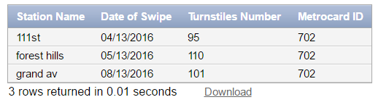

**2. Identify the swipe history of customer ken zou last 3 year. Display the date of swipe, station name and turnstile. Order by date.**

**select** station.SNAME **AS** "Station Name", swipe.DATEOFSWIPE **AS** "Date of Swipe", turnstiles.TID **AS** "Turnstiles Number"

**from** station,turnstiles,swipe

**where** swipe.TID=turnstiles.TID **and** turnstiles.sid=station.sid **and** swipe.syear >2014 **and** swipe.syear<2017

**and** swipe.CID **in**

(**select** c.cid

**from** customers c

**where** c.cfirstname = 'ken' **and** c.clastname='zou')

**order by** DATEOFSWIPE ASC;

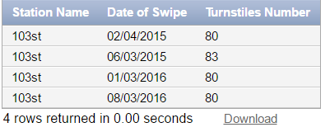

**3. Identify the number of swipes and total amount spent by all customers yesterday. Display four columns: customer name, MetroCard number of swipes and total spent. Display one row for each customer. Order by customer name.**

**select** c.cfirstname|| ' ' || c.clastname **AS** "Customer Name",count(swipe.swid) **AS** " Metrocard number of swipes",'$'|| ' ' ||f.farecost*count(swipe.swid) **AS** "Total Spent"

**from** swipe,customers c,customers_fare f

**where** swipe.syear=2017 **and** swipe.smonth=4 **and** swipe.sday=13 **and** c.cid=swipe.cid **and** c.fareid=f.fareid

**group by** c.cfirstname, c.clastname,f.farecost

**order by** c.cfirstname, c.clastname;

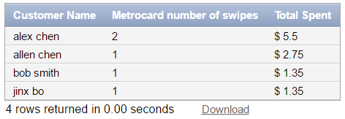

**4. Identify the number of swipes by fare type this month. Display three columns: fare type, number of swipes and total spent. Display one row for each fare type. Use a function to answer this question.**

**select** f.faretype **AS** "Fare Type",count(swipe.swid) **AS** " Metrocard number of swipes",'$'|| ' ' ||f.farecost*count(swipe.swid) **AS** "Total Spent"

**from** swipe,customers c,customers_fare f

**where** swipe.syear=2017 **and** swipe.smonth=4 **and** c.cid=swipe.cid **and** c.fareid=f.fareid

**group by** f.faretype,f.farecost;

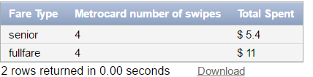

**5. Add $100 to all active MetroCard’s with a low balance for customers that provided a credit card. Identify the SQL required to implement.**

**select** *

**from** metrocard

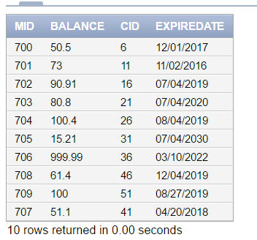

**update** metrocard

**set** balance=balance+100

**where** balance <20 and cid in

                             (select cid

                              from customer_method

                               where mtype='credit');

**select** *

**from** metrocard

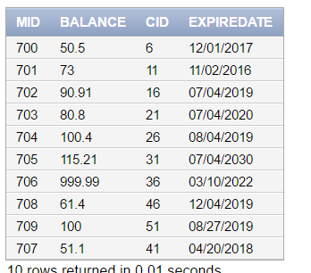

**6. Identify MetroCard’s not used in the last month. Display the MetroCard ID. Use a nested select to answer this question.**

**select** metrocard.mid **AS** " Metrocard ID"

**from** metrocard

**where** metrocard.mid **not in**

(**select** swipe.mid

**from** swipe

**where** swipe.dateofswipe < to_date('MAR-15-2017','MON-DD-YYYY') and swipe.dateofswipe > to_date('APR-15-2017','MON-DD-YYYY'));

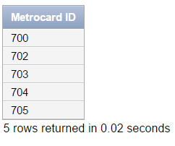

**7. Identify customers with no activity in the last year. Display the customer name and email. Use a nested select to answer this question.**

**select** c.cfirstname|| ' ' || c.clastname **AS** "Customer Name",c.email

**from** customers c

**where** c.cid **not in**

(**select** s.cid

**from** swipe s

**where** s.dateofswipe> = to_date('MAR-15-2016','MON-DD-YYYY') and s.dateofswipe<=to_date('MAR-15-2017','MON-DD-YYYY'));

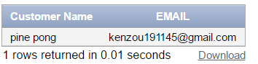

**8. Identify the top ten station with the most traffic. Display the station name, number of entries or exits. Display the busiest station first. Use a function to answer this question.**

**select** s.sname **AS** "Station NAME",sum(t.numofexit) **AS** "Number of exit"

**from** station s, turnstiles t

**where** s.sid=t.sid **and** ROWNUM <= 10

**group by** s.sname

**order by** sum(t.numofexit) **DESC ／／ or order by 2 since its in the second col of select**

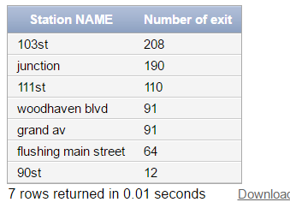

**9. Increase fares by 12%. Identify the SQL required to implement.**

**select** (f.farecost*1.12) **AS** " Increase fare by 12%"

**from** customers_fare f

**where** f.farecost >0;

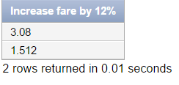

OR

**update** customers_Fare

**set** farecost=farecost*1.12;

**commit;**

**select** f.farecost

**from** customers_Fare f;

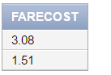

**10. Swipe the MetroCard at the 103st station today and then display the customer id. Identify the SQL required to implement.**

**insert into** swipe(SWID,MID,CID,TID,DATEOFSWIPE,SYEAR,SMONTH,SDAY)

**values**(seq_swipe.nextval,701,6,80,to_date('mar-15-2017','mon-dd-yyyy'),2017,3,15);

**update** metrocard

**set balance**= balance -2.75

**where** cid=11 and mid=701;

**select** c.cfirstname|| ' ' || c.clastname **AS** "Customer Name"

**from** customers c,metrocard m

**where** m.mid=701 and m.cid=c.cid

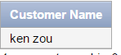

**11. A MetroCard expired. Transfer the balance to a new card. Afterwards, go to school for class. Then go home After classes are over. Identify the SQL required to implement.**

**insert into** metrocard(Mid,balance,cid,expiredate)

values(710,null,null,'11/2/2020');

**update** metrocard

**set (**balance,cid)=(select balance,cid

**from** metrocard

**where** mid=701)

**where** mid=710;

**select** *

**from** metrocard

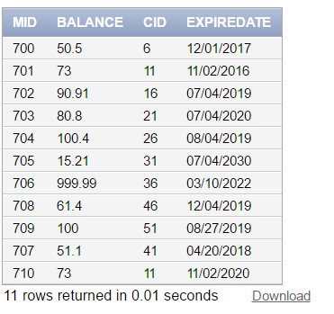

**insert into** swipe(SWID,MID,CID,TID,DATEOFSWIPE,SYEAR,SMONTH,SDAY)

**values**(seq_swipe.nextval,710,6,80,to_date('mar-15-2017','mon-dd-yyyy'),2017,3,15);

**update** metrocard

**set balance**= balance -2.75

**where** balance >=2.75 and cid=11 and mid=710;

**select** *

**from** metrocard

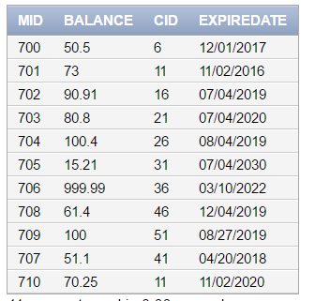

**update** metrocard

**set balance**= balance -2.75

**where** balance >=2.75 and cid=11 and mid=710;

**select** *

**from** metrocard

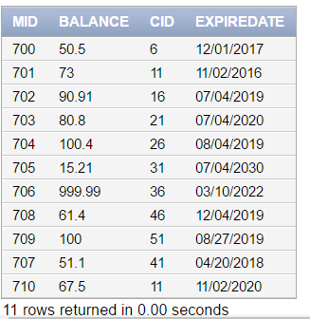

**12. Identify the number of turnstile entries or exits on the R line. Display two columns: station name and number of entries or exits. Display one row for each station name. Order the station names in the same order of the stops. Use a function to answer this question.**

**select**s.sname **AS** "Station NAME",sum(t.numofexit)**AS** "Number of exit"

**from** station s, turnstiles t, station_line l

**where** s.sid=t.sid **and** l.sid=t.sid **and** l.sid=s.sid **and** l.linename='R'

**group by** s.sname,s.station#

**order by** s.station#;

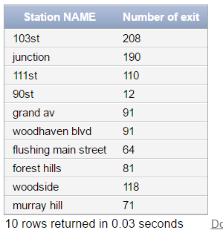

**13. Display the table structure using the SQL Describe operation.**

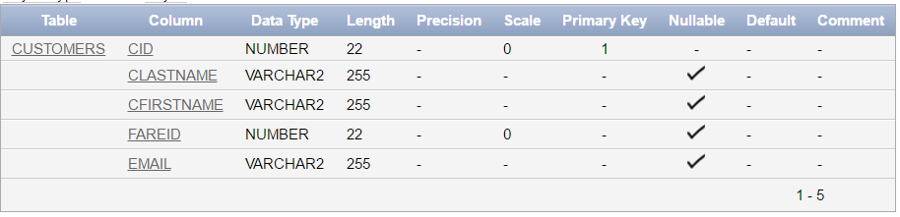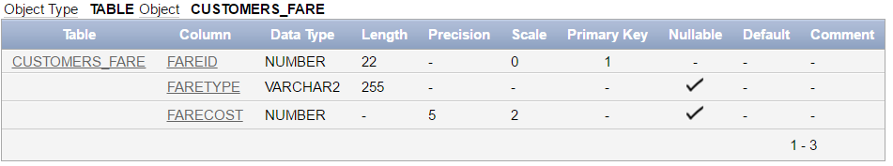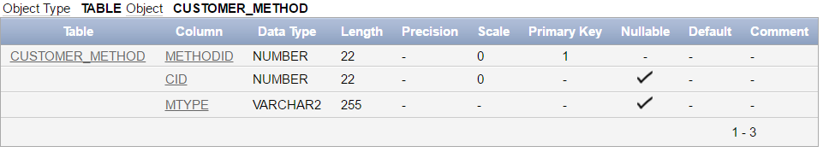

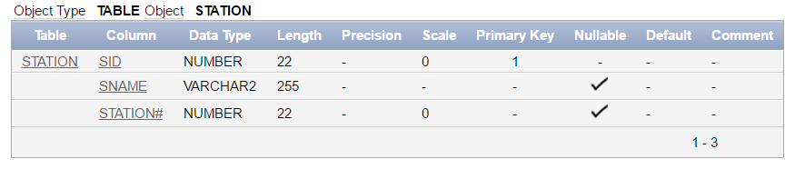

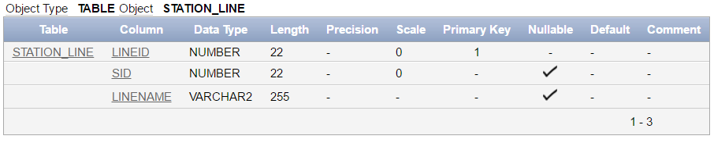

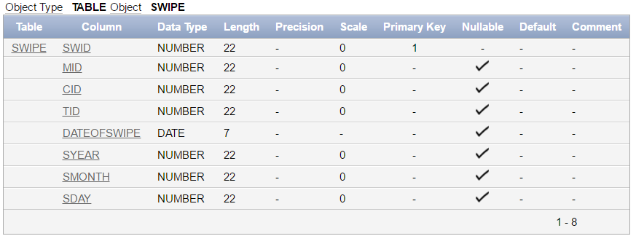

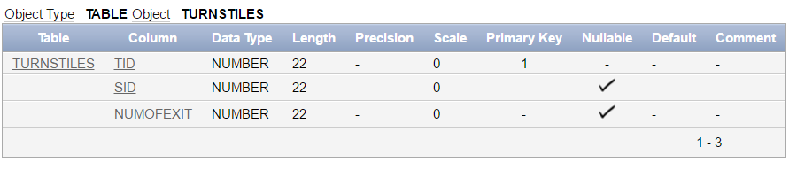

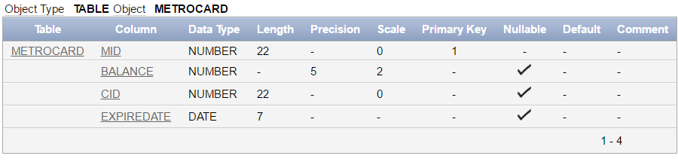

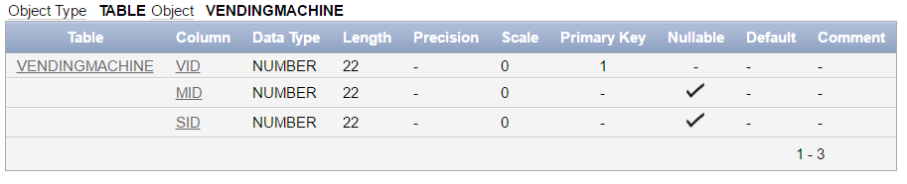

**14. Display the Oracle version by entering select * from product_component_version;**

